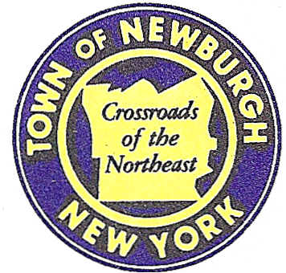

TOWN OF NEWBURGH
_______Crossroads of the Northeast __________________________
OLD TOWN HALL
308 GARDNERTOWN ROAD NEWBURGH, NEW YORK 12550

PLANNING BOARD
JOHN P. EWASUTYN, CHAIRMAN
TELEPHONE 845-564-7804
FAX 845-564-7802
E-MAIL: planningboard@townofnewburgh.org

PLANNING BOARD AGENDA

July 18th, 2019

*PLEASE NOTE: The Planning Board Meeting will start at 7:00 P.M. and all Applicants/Representatives
are to be present at that time. The Meeting will be held in the Meeting Room of Town Hall,
located at 1496 Route 300, Newburgh NY.*

- Royal Pools & Spas (19-13) PUBLIC HEARING
49 Route 17K
Section 100, Block 5, Lot 1
Zone: IB
Rep: Marci Wade- Lewis Sign Co., LLC
26 Flourescent Drive
Slate Hill , NY 10973

- 182 South Plank Rd. (19-08) PUBLIC HEARING
182 South Plank Rd.
Section 64, Block 2, Lot 8.21
Zone: B.
Rep: Maser Consulting
555 Hudson Valley Ave. Suite 101
New Windsor, NY 12553

- Xxxxxx (19)
Lxxxxxxxxxxxxx
Section 86, Block 1 Lot 39.22 & 39.23
Zone: IB
Rep: XXXXXXX

*WORK SESSION*
Project Readiness Discussion scheduled for 5:30 p.m. in the Meeting Room of
Town Hall on Thursday, July 18th, 2019

PLANNING BOARD BUSINESS
WORK SESSION

*WORK SESSION*
Project Readiness Discussion scheduled for 5:30 p.m. in the Meeting Room of
Town Hall on Thursday, July 18th, 2019.*

